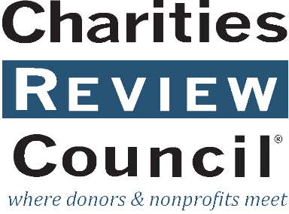
Whistleblower Policy
  - for [OrganizationName]

Article I: Purpose
[OrganizationName] (the “Organization”) requires its employees and volunteers, including its Board and committee members, to observe high standards of business and personal ethics in the conduct of their duties and responsibilities. As employees and representatives of the organization, it is important to comply with all applicable laws and regulatory requirements.

Article II: Reporting Responsibility
The Organization has an “Open Door” policy and encourages everyone to share their concerns, and complaints regarding the Organization and its operations with the appropriate Organization authority. A board member or committee member should present his or her concerns to the Chair of the Board. An employee or volunteer should present his or her concerns to the Executive Director. However, if a board member is not comfortable speaking with the Chair of the Board or is not comfortable with the Chair of the Board’s response, or if an employee or volunteer is not comfortable speaking with the Executive Director or is not satisfied with the Executive Director’s response, the Board member, employee, or volunteer is encouraged to speak with anyone on the Board whom the individual is comfortable in approaching, or to directly contact the organization’s outside legal counsel, whose contact information can be obtained from the Executive Director.

Article III: Requirement of Good Faith
Anyone filing a complaint concerning a violation or suspected violation of the Organization’s policies, or any laws or regulation requirements, must be acting in good faith and have reasonable grounds for believing the information disclosed indicates a violation. Any allegations that prove not to be substantiated and which prove to have been made maliciously or knowingly to be false will be viewed as a serious disciplinary offense.

Article IV: No Retaliation
No individual who in good faith reports a violation shall suffer harassment, retaliation, or any adverse employment consequence. Any individual who retaliates against someone who has reported a violation in good faith is subject to discipline up to and including termination of employment or volunteer status. This Whistleblower Policy is intended to encourage and enable all individuals to report violations and concerns within the Organization to the Organization prior to seeking resolution outside the Organization.

Article V: Compliance Officer
The Organization’s Executive Director, working with the Chair of the Board, will act as the Organization’s Compliance Officer. The Compliance Officer is responsible for investigating and resolving complaints and allegations concerning violations of all applicable laws and regulations, including the Organization’s bylaws and/or Code of Conduct. The Board Chair, or the Chair’s designee, will take on the Compliance Officer role if the complaint involves the Executive Director. If the complaint involves both the Executive Director and Board Chair, the Vice Chair will carry out the functions of the Compliance Officer.

Article VI: Accounting and Auditing Matters
The Finance Committee of the Board of Directors shall address all reported concerns or complaints regarding the Organization’s accounting practices, internal controls, or auditing. The Compliance Officer shall immediately notify the Finance Committee of any such complaint and work with the Committee until the matter is resolved.

Article VII: Confidentiality
Violations or suspected violations may be submitted anonymously or on a confidential basis by the complainant. Reports of violations or suspected violations will be kept confidential to the extent possible, consistent with the need to conduct an adequate investigation.

Article VIII: Handling of Reported Violations
The Compliance Officer, or the person responsible for carrying out the Compliance Officer’s role with respect to a reported or suspected violation, will acknowledge receipt of the reported violation or suspected violation by writing a letter (or e-mail) to the complainant within five business days. All reports will be promptly investigated, and appropriate corrective action will be taken if warranted by the investigation.

